LOAN PORTFOLIO PERFORMANCE AND CREDIT RISK ANALYSIS REPORT
-- =========================================
-- 3. CORE KPI METRICS
-- =========================================
SELECT COUNT(id) AS total_applications FROM finance;
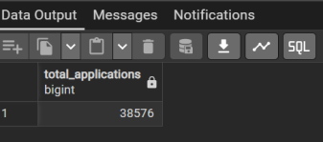
SELECT COUNT(id)
FROM finance
WHERE EXTRACT(MONTH FROM issue_date)=12 AND EXTRACT(YEAR FROM issue_date)=2021;

SELECT COUNT(id)
FROM finance
WHERE EXTRACT(MONTH FROM issue_date)=11 AND EXTRACT(YEAR FROM issue_date)=2021;

SELECT SUM(loan_amount) AS total_funded_amount FROM finance;

SELECT SUM(total_payment) AS total_payment FROM finance;

SELECT 'Total Applications' AS measure_name,
COUNT(id) AS measure_value
FROM finance

UNION ALL

SELECT 'Applications - December 2021',
COUNT(id)
FROM finance
WHERE EXTRACT(MONTH FROM issue_date) = 12
AND EXTRACT(YEAR FROM issue_date) = 2021

UNION ALL

SELECT 'Applications - November 2021',
COUNT(id)
FROM finance
WHERE EXTRACT(MONTH FROM issue_date) = 11
AND EXTRACT(YEAR FROM issue_date) = 2021

UNION ALL

SELECT 'Total Funded Amount',
SUM(loan_amount)
FROM finance

UNION ALL

SELECT 'Total Payment Received',
SUM(total_payment)
FROM finance;

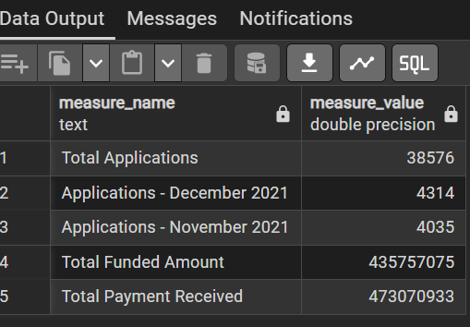

SELECT 'Average Interest Rate (%)' AS measure_name,
ROUND(AVG(int_rate)::numeric * 100, 2) AS measure_value
FROM finance

UNION ALL

SELECT 'Average DTI (%)',
ROUND(AVG(dti)::numeric * 100, 2)
FROM finance

-- =========================
-- GOOD LOAN METRICS
-- =========================
UNION ALL

SELECT 'Good Loan Percentage (%)',
ROUND(
COUNT(CASE WHEN loan_status IN ('Fully Paid','Current') THEN id END)
* 100.0 / COUNT(id), 2
)
FROM finance

UNION ALL

SELECT 'Good Loan Applications',
COUNT(CASE WHEN loan_status IN ('Fully Paid','Current') THEN id END)
FROM finance

UNION ALL

SELECT 'Total Funded Amount (Good Loans)',
SUM(CASE WHEN loan_status IN ('Fully Paid','Current') THEN loan_amount END)
FROM finance

UNION ALL

SELECT 'Total Payment Received (Good Loans)',
SUM(CASE WHEN loan_status IN ('Fully Paid','Current') THEN total_payment END)
FROM finance

-- =========================
-- BAD LOAN METRICS
-- =========================
UNION ALL

SELECT 'Bad Loan Applications',
COUNT(CASE WHEN loan_status = 'Charged Off' THEN id END)
FROM finance

UNION ALL

SELECT 'Bad Loan Percentage (%)',
ROUND(
COUNT(CASE WHEN loan_status = 'Charged Off' THEN id END)
* 100.0 / COUNT(id), 2
)
FROM finance

UNION ALL

SELECT 'Total Funded Amount (Bad Loans)',
SUM(CASE WHEN loan_status = 'Charged Off' THEN loan_amount END)
FROM finance

UNION ALL

SELECT 'Total Payment Received (Bad Loans)',
SUM(CASE WHEN loan_status = 'Charged Off' THEN total_payment END)
FROM finance;
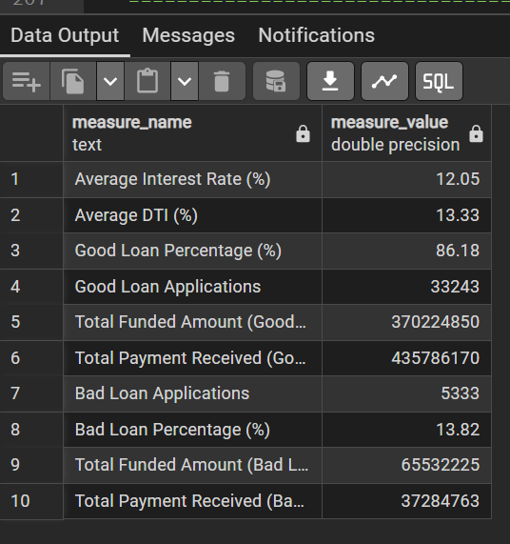

-- =========================================
-- 7. MONTHLY LOAN TREND
-- ======================================
WITH monthly_trend_analysis AS (
SELECT
TRIM(TO_CHAR(issue_date::date, 'month')) AS month_name,
EXTRACT(MONTH FROM issue_date) AS month_no,

COUNT(*) AS total_loans,

COUNT(
CASE
WHEN loan_status IN ('Fully Paid','Current') THEN id
END
) AS good_loans,

COUNT(
CASE
WHEN loan_status = 'Charged Off' THEN id
END
) AS bad_loans

FROM finance
GROUP BY 1,2
)

SELECT
month_no,
month_name,
total_loans,

-- ======================
-- GOOD LOANS
-- ======================
good_loans,
LAG(good_loans) OVER (ORDER BY month_no) AS prev_good_loans,
good_loans - LAG(good_loans) OVER (ORDER BY month_no) AS good_loan_diff,

ROUND(
(
100.0 * (good_loans - LAG(good_loans) OVER (ORDER BY month_no))
/ NULLIF(LAG(good_loans) OVER (ORDER BY month_no), 0)
)::numeric,
2
) AS good_loan_pct_change,

-- ======================
-- BAD LOANS
-- ======================
bad_loans,
LAG(bad_loans) OVER (ORDER BY month_no) AS prev_bad_loans,
bad_loans - LAG(bad_loans) OVER (ORDER BY month_no) AS bad_loan_diff,

ROUND(
(
100.0 * (bad_loans - LAG(bad_loans) OVER (ORDER BY month_no))
/ NULLIF(LAG(bad_loans) OVER (ORDER BY month_no), 0)
)::numeric,
2
) AS bad_loan_pct_change,

-- ======================
-- SMART INSIGHT LABEL
-- ======================
CASE
WHEN
good_loans - LAG(good_loans) OVER (ORDER BY month_no) > 0
AND
bad_loans - LAG(bad_loans) OVER (ORDER BY month_no) < 0
THEN 'healthy growth'

WHEN
good_loans - LAG(good_loans) OVER (ORDER BY month_no) > 0
AND
bad_loans - LAG(bad_loans) OVER (ORDER BY month_no) > 0
THEN 'risky growth'

WHEN
good_loans - LAG(good_loans) OVER (ORDER BY month_no) < 0
AND
bad_loans - LAG(bad_loans) OVER (ORDER BY month_no) > 0
THEN 'deteriorating'

WHEN
good_loans - LAG(good_loans) OVER (ORDER BY month_no) < 0
AND
bad_loans - LAG(bad_loans) OVER (ORDER BY month_no) < 0
THEN 'weak activity'

ELSE 'stable'
END AS loan_trend_status

FROM monthly_trend_analysis

ORDER BY month_no;
--OR
WITH monthly_trend_analysis AS (
SELECT
TRIM(TO_CHAR(issue_date::date, 'month')) AS month_name,
EXTRACT(MONTH FROM issue_date) AS month_no,

COUNT(*) AS total_loans,

COUNT(
CASE
WHEN loan_status IN ('Fully Paid','Current') THEN id
END
) AS good_loans,

COUNT(
CASE
WHEN loan_status = 'Charged Off' THEN id
END
) AS bad_loans

FROM finance
GROUP BY 1,2
)

SELECT
month_no,
month_name,
total_loans,

-- ======================
-- GOOD LOANS
-- ======================
good_loans,
LAG(good_loans) OVER (ORDER BY month_no) AS prev_good_loans,
good_loans - LAG(good_loans) OVER (ORDER BY month_no) AS good_loan_diff,

ROUND(
(
100.0 * (good_loans - LAG(good_loans) OVER (ORDER BY month_no))
/ NULLIF(LAG(good_loans) OVER (ORDER BY month_no), 0)
)::numeric,
2
) AS good_loan_pct_change,

-- ======================
-- BAD LOANS
-- ======================
bad_loans,
LAG(bad_loans) OVER (ORDER BY month_no) AS prev_bad_loans,
bad_loans - LAG(bad_loans) OVER (ORDER BY month_no) AS bad_loan_diff,

ROUND(
(
100.0 * (bad_loans - LAG(bad_loans) OVER (ORDER BY month_no))
/ NULLIF(LAG(bad_loans) OVER (ORDER BY month_no), 0)
)::numeric,
2
) AS bad_loan_pct_change

FROM monthly_trend_analysis

ORDER BY month_no;

--OR
WITH monthly_trend_analysis AS (
SELECT
TRIM(TO_CHAR(issue_date::date, 'month')) AS month_name,
EXTRACT(MONTH FROM issue_date) AS month_no,
COUNT(*) AS total_loans,

COUNT(CASE WHEN loan_status IN ('Fully Paid','Current') THEN id END) AS good_loans,
COUNT(CASE WHEN loan_status = 'Charged Off' THEN id END) AS bad_loans

FROM finance
GROUP BY 1,2
),

lagged_data AS (
SELECT
*,
LAG(good_loans) OVER (ORDER BY month_no) AS prev_good_loans,
LAG(bad_loans) OVER (ORDER BY month_no) AS prev_bad_loans
FROM monthly_trend_analysis
)

SELECT
month_no,
month_name,
total_loans,

-- GOOD LOANS
good_loans,
prev_good_loans,
good_loans - prev_good_loans AS good_loan_diff,

ROUND(
100.0 * (good_loans - prev_good_loans)
/ NULLIF(prev_good_loans, 0), 2
) AS good_loan_pct_change,

-- BAD LOANS
bad_loans,
prev_bad_loans,
bad_loans - prev_bad_loans AS bad_loan_diff,

ROUND(
100.0 * (bad_loans - prev_bad_loans)
/ NULLIF(prev_bad_loans, 0), 2
) AS bad_loan_pct_change,

-- ✅ FIXED SMART INSIGHT
CASE
WHEN prev_good_loans IS NULL OR prev_bad_loans IS NULL
THEN 'no prior data'

WHEN (good_loans - prev_good_loans) > 0
AND (bad_loans - prev_bad_loans) < 0
THEN 'healthy growth'

WHEN (good_loans - prev_good_loans) > 0
AND (bad_loans - prev_bad_loans) > 0
THEN 'risky growth'

WHEN (good_loans - prev_good_loans) < 0
AND (bad_loans - prev_bad_loans) > 0
THEN 'deteriorating'

WHEN (good_loans - prev_good_loans) < 0
AND (bad_loans - prev_bad_loans) < 0
THEN 'weak activity'

ELSE 'stable'
END AS loan_trend_status

FROM lagged_data
ORDER BY month_no;

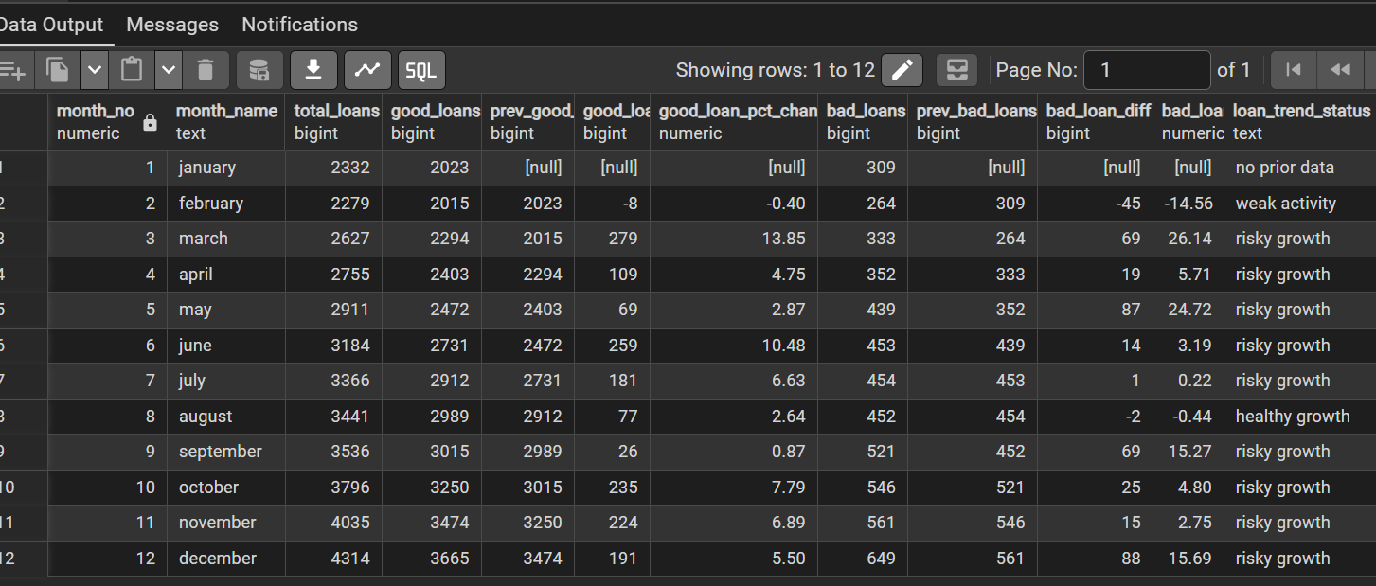

-- =========================================
-- 9. RATE OF REPAYMENT BY EMPLOYEE TENURE
-- =========================================
SELECT
emp_length AS years_of_emp,
SUM(CASE WHEN loan_status='Charged Off' THEN total_payment ELSE 0 END) AS actual_bad_loan_repaid,
SUM(CASE WHEN loan_status='Charged Off'
THEN loan_amount + (loan_amount*int_rate) ELSE 0 END) AS expected_bad_loan_payment,
SUM(CASE WHEN loan_status='Charged Off'
THEN loan_amount + (loan_amount*int_rate) ELSE 0 END)
- SUM(CASE WHEN loan_status='Charged Off'
THEN total_payment ELSE 0 END) AS loss_on_bad_loans
FROM finance
GROUP BY emp_length
ORDER BY expected_bad_loan_payment DESC;
--OR
SELECT
emp_length AS years_of_emp,

COUNT(
CASE
WHEN loan_status = 'Charged Off' THEN 1
END
) AS bad_loan_count,

SUM(
CASE
WHEN loan_status = 'Charged Off'
THEN total_payment
ELSE 0
END
) AS actual_bad_loan_repaid,

SUM(
CASE
WHEN loan_status = 'Charged Off'
THEN loan_amount + (loan_amount * int_rate)
ELSE 0
END
) AS expected_bad_loan_payment,

SUM(
CASE
WHEN loan_status = 'Charged Off'
THEN loan_amount + (loan_amount * int_rate)
ELSE 0
END
)
-
SUM(
CASE
WHEN loan_status = 'Charged Off'
THEN total_payment
ELSE 0
END
) AS loss_on_bad_loans,

SUM(
CASE
WHEN loan_status = 'Charged Off'
THEN total_payment
ELSE 0
END
)
/
NULLIF(
COUNT(
CASE
WHEN loan_status = 'Charged Off' THEN 1
END
),
0
) AS avg_repaid_per_bad_loan

FROM finance
WHERE loan_status <> 'Current'
GROUP BY emp_length
ORDER BY 6 DESC;

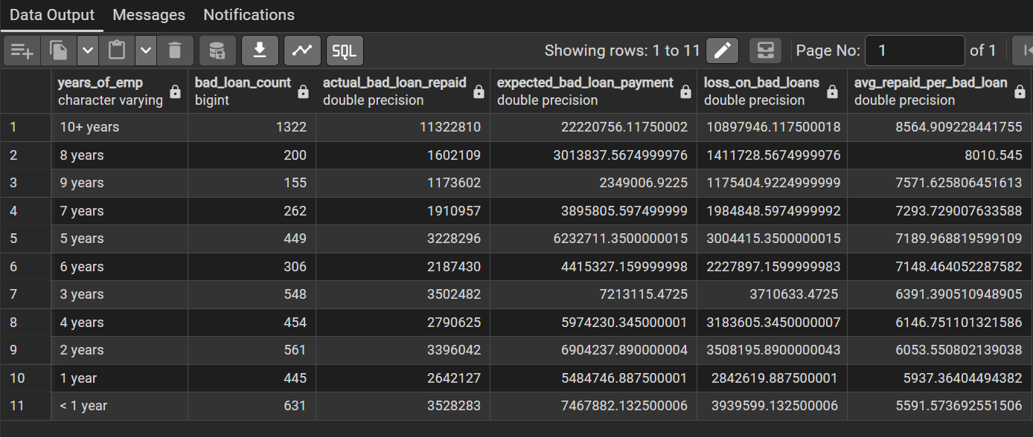

-- =========================================
-- 10.RECOVERY RATE BY HOME OWNERSHIP
-- =========================================
SELECT
home_ownership,
SUM(loan_amount + (loan_amount*int_rate)) AS expected,
SUM(total_payment) AS repaid,
SUM(total_payment) /
NULLIF(SUM(loan_amount + (loan_amount*int_rate)),0) AS recovery_rate,
ROUND(
(100.0*SUM(total_payment) /
NULLIF(SUM(loan_amount + (loan_amount*int_rate)),0))::numeric,
2
) AS recovery_pct
FROM finance
WHERE loan_status != 'Current'
GROUP BY home_ownership
ORDER BY 3 DESC;
--OR
SELECT home_ownership,

COUNT(*) AS loan_count,

SUM(loan_amount + (loan_amount * int_rate)) AS expected,

SUM(total_payment) AS repaid,

SUM(total_payment) /
NULLIF(SUM(loan_amount + (loan_amount * int_rate)), 0) AS recovery_rate,

ROUND(
(100.0 * SUM(total_payment) /
NULLIF(SUM(loan_amount + (loan_amount * int_rate)), 0))::numeric,
2
) AS recovery_pct,

-- ✅ NEW COLUMN
SUM(total_payment) /
NULLIF(COUNT(*), 0) AS avg_repaid_per_loan

FROM finance
WHERE loan_status != 'Current'
GROUP BY home_ownership
ORDER BY 7 DESC;

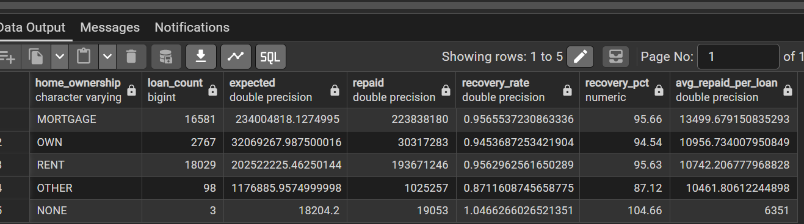

-- =========================================
-- 10.RECOVERY RATE BY HOME OWNERSHIP
-- =========================================
SELECT
home_ownership,
SUM(loan_amount + (loan_amount*int_rate)) AS expected,
SUM(total_payment) AS repaid,
SUM(total_payment) /
NULLIF(SUM(loan_amount + (loan_amount*int_rate)),0) AS recovery_rate,
ROUND(
(100.0*SUM(total_payment) /
NULLIF(SUM(loan_amount + (loan_amount*int_rate)),0))::numeric,
2
) AS recovery_pct
FROM finance
WHERE loan_status != 'Current'
GROUP BY home_ownership
ORDER BY 3 DESC;
--OR
SELECT home_ownership,

COUNT(*) AS loan_count,

SUM(loan_amount + (loan_amount * int_rate)) AS expected,

SUM(total_payment) AS repaid,

SUM(total_payment) /
NULLIF(SUM(loan_amount + (loan_amount * int_rate)), 0) AS recovery_rate,

ROUND(
(100.0 * SUM(total_payment) /
NULLIF(SUM(loan_amount + (loan_amount * int_rate)), 0))::numeric,
2
) AS recovery_pct,

-- ✅ NEW COLUMN
SUM(total_payment) /
NULLIF(COUNT(*), 0) AS avg_repaid_per_loan

FROM finance
WHERE loan_status != 'Current'
GROUP BY home_ownership
ORDER BY 7 DESC;
